Component Principles
Table of Contents
Component Cohesion 3
The Reuse/Release Equivalence Principle 3
The Common Closure Principle 3
The Common Reuse Principle 4
Component Coupling 5
The Acyclic Dependencies Principle 5
The Stable Dependencies Principle 6
The Stable Abstractions Principle 8

Large software systems are built out of smaller components. The components are the units of deployment, the smallest units that can be deployed as a part of the system. In Java, these are .jar files. In Ruby, these are .gem files. In .Net, these are .dll files. Well-designed components always retain the ability to be independently deployable, and therefore, independently developable.

Component Cohesion
A single component could contain multiple classes. These classes should all be related to each other and working to achieve the same goal, i.e. the component should be cohesive.
To achieve component cohesion, we can follow three principles:
- The Reuse/Release Equivalence Principls (REP)
- The Common Closure Principle (CCP)
- The Common Reuse Principle (CRP)

The Reuse/Release Equivalence Principle
The Reuse/Release Equivalence Principle (REP) states that classes and modules that are grouped together into a component should be releasable together. The releases should follow a release process and should maintain release numbers. Otherwise, people who wish to reuse the software component cannot and will not do so.

The Common Closure Principle
The Common Closure Principle (CCP) states that classes that change for the same reasons and at the same times should be part of the same component. Otherwise, they should be in different components.
Similar to SRP, CCP essentially says that a component should not have multiple reasons to change.

The Common Reuse Principle
The Common Reuse Principle (CRP) states that we should not force users of a component to depend on things they do not need. Essentially, classes and modules that tend to be reused together should be in the same component, while those that are not tightly bound to each other should be in different components.

Component Coupling
The coupling between components refers to how dependent they are on each other. There are three principles we will be looking into related to component coupling:
- The Acyclic Dependencies Principle
- The Stable Dependencies Principle
- The Stable Abstractions Principle

The Acyclic Dependencies Principle
The Acyclic Dependencies Principle (ADP) states that we should design our components such that there are no cycles in the dependency graph for the components.

The dependency graph above shows a violation of ADP. We can fix this situation by using interfaces.

The Stable Dependencies Principle
Stability is related to the amount of work required to make a change. Stable means hard to change. Instable means easy to change.
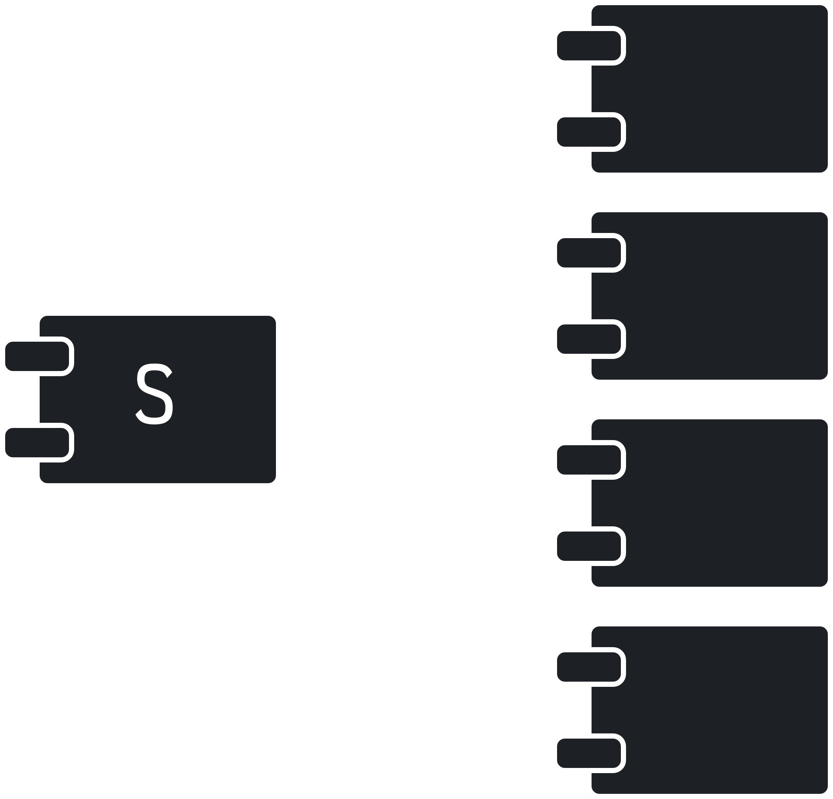
In the diagram above, the component S has four other components that are dependent on it. S is responsible to those components. Thus, it is very stable, since changing S would force us to change all four components. Notice that we do not relate stability to the complexity of the component.
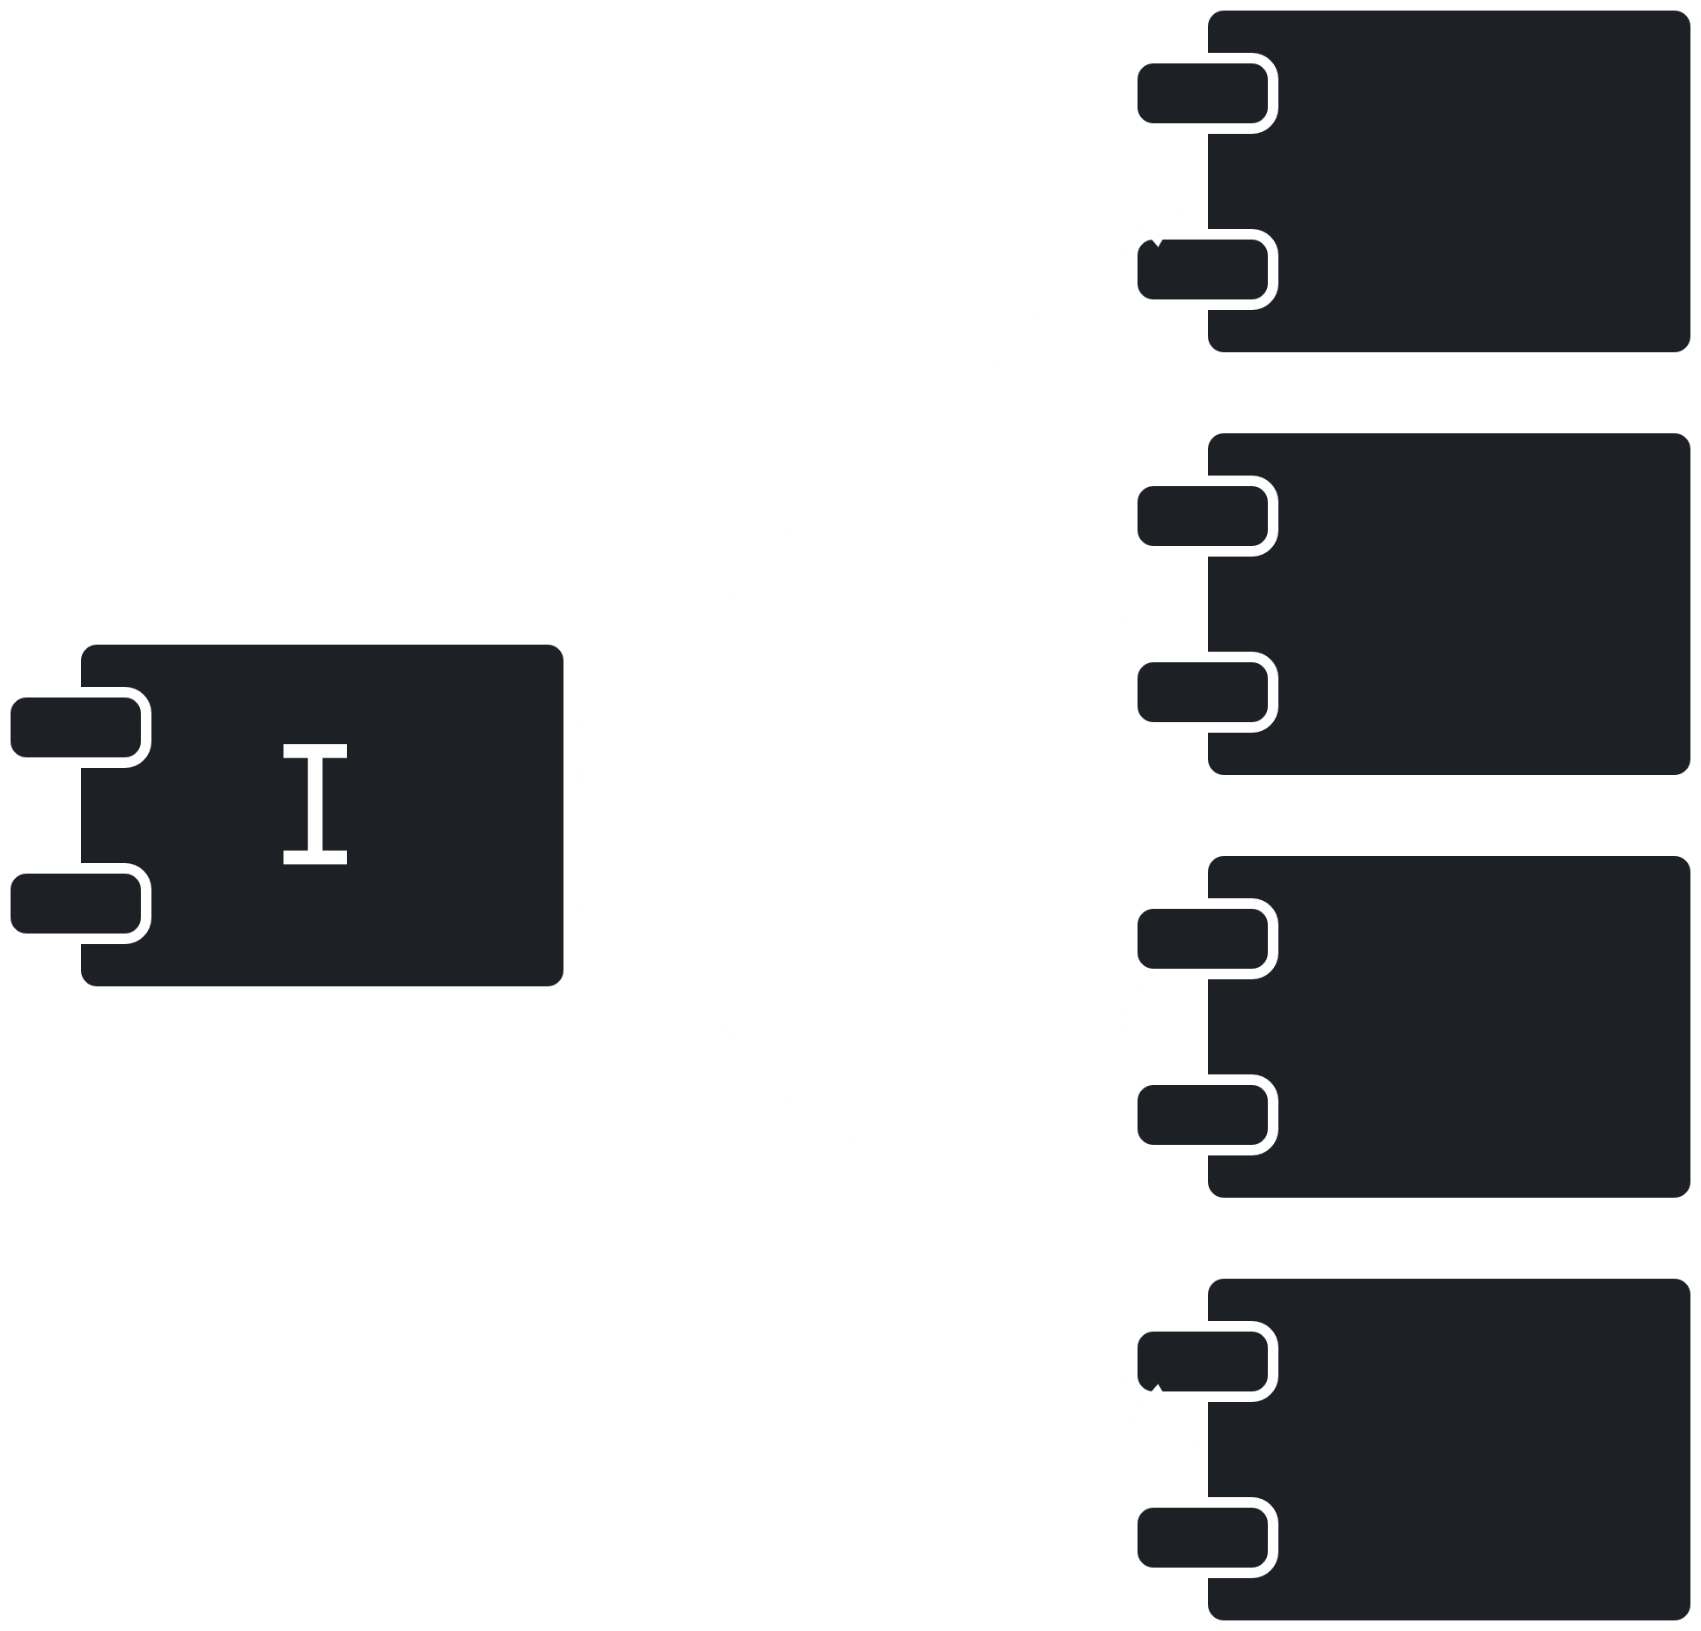
Conversely, in the diagram above, the component I is independent and thus will have no issues changing. It is instable.
The Stable Dependency Principle (SDP) states that components should depend in the direction of stability. This means that less stable components should depend on more stable ones.

Calculating Stability
To calculate stability, we need to count the number of dependencies entering and leaving a component.
The number of classes outside the component that depend on classes inside the component is called the Incoming Dependencies, $Fan_{in}$.
The number classes inside the component that depend on classes outside the component is called the Outgoing Dependencies, $Fan_{out}$.
Instability is calculated as
$$I=\frac{Fan_{out}}{Fan_{in}+Fan_{out}}$$
This metric has a range from $0$ to $1$, with $1$ being maximum instability and $0$ being maximum stability.
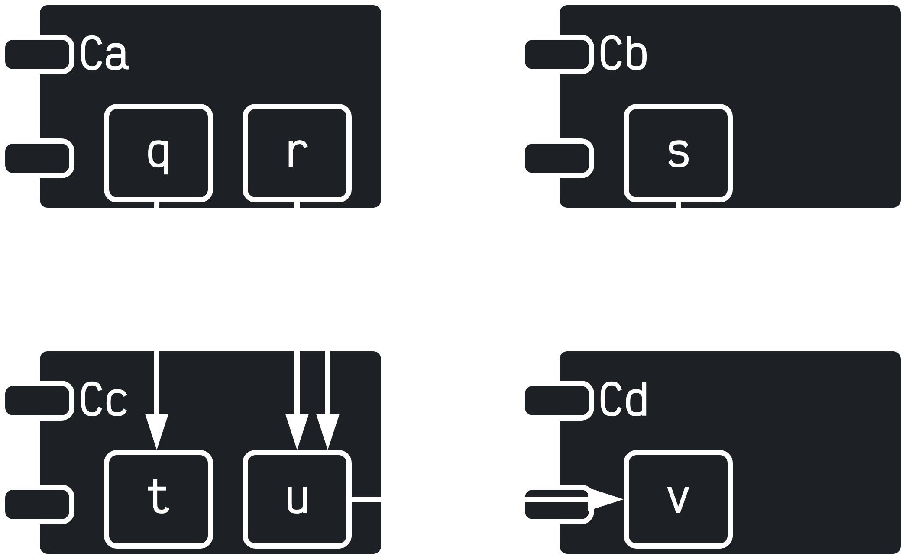
For the component $C_{C}$ in the diagram above,
$$I=\frac{1}{1+3}=0.25$$

The Stable Abstractions Principle
The Stable Abstraction Principle (SAP) sets up a relationship between stability and abstraction. The more stable a component is, the more abstract it should be. If a component is to be stable, it needs to have interfaces and abstract classes so that it is extensible.

Measuring Abstraction
Abstraction is simple the ratio of interfaces and abstract classes in a component to the total number of classes in the component.
$$A=\frac{N_{a}}{N_{c}}$$
The metric $A$ ranges from $0$ to $1$, with $1$ indicating that the component consists solely of abstract classes and $0$ indicating the component has no abstract classes.

